# Infrastructure Architecture Diagram

Cloud layer

Application on top of cloud layer

2. Application (MVC) Architecture Diagram

# 5. EIP Architecture diagram (Multi-Company Environment)

Replace Company with Company

Document the folder approach

How to organize the site for each customer: folder format

Diagram

Red line: when administrator sign in

Blue line: when end user sign in

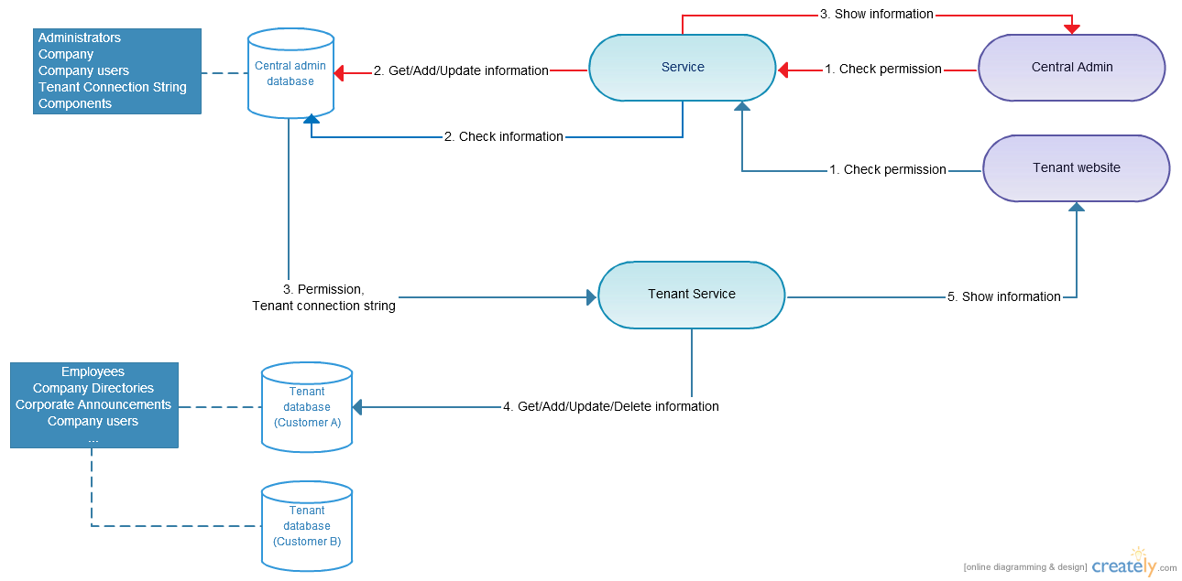

Documentation

## Administrator sign in

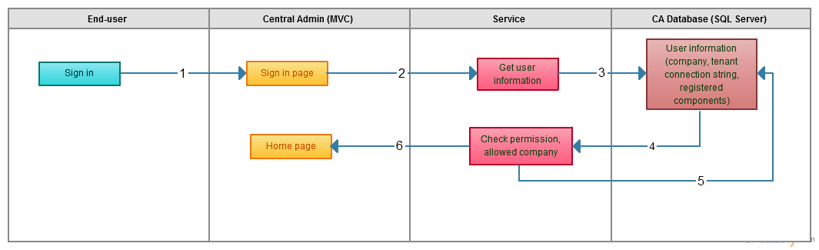

1. Administrator sign in:
   1. Administrator sign in to Central Admin website (ex: <https://ca.kumo-eip.com>).
   2. Central Admin website send input information to the Service.
   3. Service use input information (username and password), connect to Central Admin database (CA database).
   4. CA database return user information (Username, password, permission) base on input information.
   5. Service check the account is valid or not. If it’s valid (username and password is correct and has admin permission), it’ll connect to the CA database to get data (company, components).
   6. Central Admin website will show data returning from Service. Administrator can add/update/delete data to CA database. When administrator add a new company, a separate database will be created for the new company by PowerShell script. To running PowerShell script when a new company is added, CA website will be hosted in Azure Virtual machine.

## End user sign in

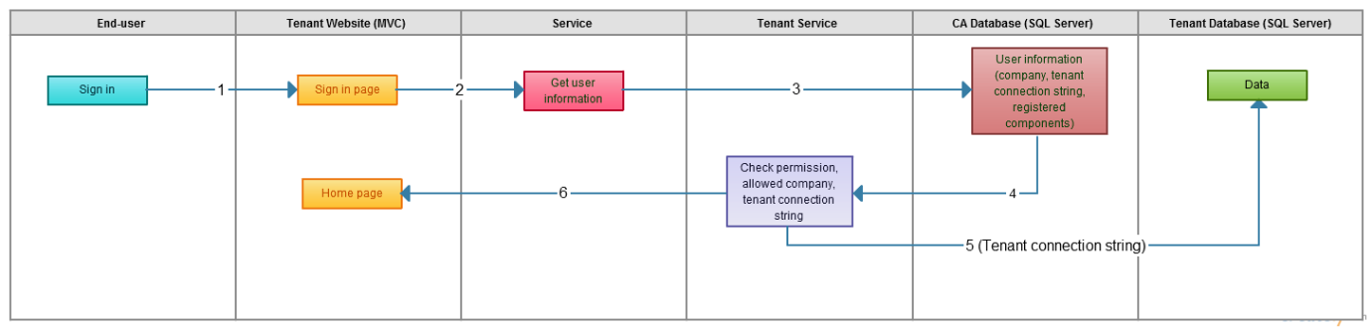

1. End user sign in:
   1. End user sign in to Company website (ex: https:// kumo-eip.com)
   2. Company website send input information to the Service.
   3. Service use input information (username and password), connect to Central Admin database (CA database) to check the account is valid or not.
   4. If it’s valid (username and password is correct), CA database will return data (company, components, company connection string) to the Company Service.
   5. Company Service will user the connection string from CA database to connect to corresponding company database and get data.
   6. Company website show data returning from Company Service.

# Application: Database Architecture Diagram

Diagram

## Central Admin core table

### Client Table

|  |  |  |  |
| --- | --- | --- | --- |
| Client Table | | | |
| Property | **Type** | **Required** | **Description** |
| Id | Number | Yes | ID, Auto generate |
| Client Name | String | Yes | Name of client |
| DBName | String | Yes | Name of database store all business data |
| DBUser | String | Yes | Username to connect database |
| DBPassword | String | Yes | Encrypt password using to for client website connect to db |
| DBServer | String | Yes | IP Address or host name of DB Server. Assume that is Azure SQL server. |
| Status | Choice | Yes | Single value using these option : Active, Inactive, Deleted, Pending, Deploying |
| SiteUrl | String | Yes |  |
| Client Code | String | Yes | The company name or Unique code to identity client in the company site |
|  |  |  |  |

Depend on business requirement, we may add some extra field to hold Client Information such as Address, Phone Number, Contact …..

### CA User table

|  |  |  |  |
| --- | --- | --- | --- |
| User | | | |
| Property | **Type** | **Required** | **Description** |
| Id | Number | Yes | ID, Auto generate |
| Username | String | Yes | User name to login to CA |
| Email | String | Yes | Email or user to receive email/reset password |
| Password | String | Yes | User password storage as hash using SHA-256 Algorithm |
| Role | String | Yes | There use will have 3 roles, CA Admin; Company Admin |
|  |  |  |  |

### Client services

|  |  |  |  |
| --- | --- | --- | --- |
| ClientService | | | |
| Property | **Type** | **Required** | **Description** |
| Id | Number | Yes | ID, Auto generate |
| Client | Dropdown | Yes | Select from client table |
| Modules | Multiple Checkbox | Yes | Select modules that current client using:  Core Module  HR  CRM  ……. |
|  |  |  |  |

## Application: Security Architecture Diagram

### Diagram

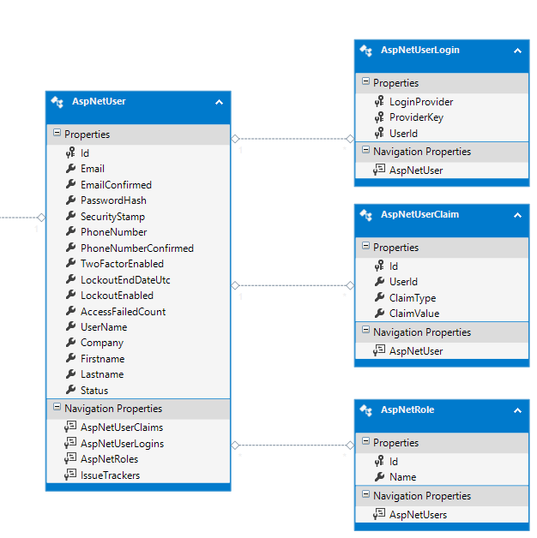

### Documentation

### User & Authentication core

User & Authentication module will delivery by [Identity Framework 2.0](http://www.asp.net/identity/overview/getting-started/introduction-to-aspnet-identity) as the basic model below. This framework was developed and being supported by Microsoft and it provide all the basic function for authentication and authorization which meet to the standard web security and flexibility.

### Core Components :InterBlock Architecture Diagram

Database structure will be design base on the features requirements. I will be develop using the latest version of Entity Framework (current version is 6.1.2).

HR

CCS

CRM

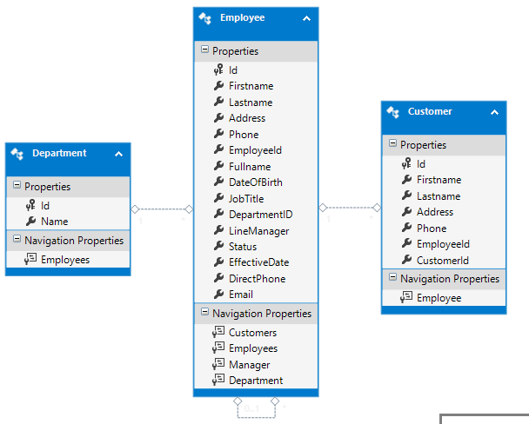

PM3

MIS

DMS

